Explainable Probabilistic Machine Learning for Predicting Drilling Fluid Loss of Circulation in Marun Oil Field
Seshu Damarla¹, Xiuli Zhu²
¹Department of Chemical and Materials Engineering, University of Alberta, Edmonton, Canada
¹e-mail: damarla@ualberta.ca
²Department of Optical-Electrical and Computer Engineering, University of Shanghai for Science and Technology, Shanghai, P. R. China
²e-mail: xiulizhu@usst.edu.cn

Table S1 Descriptive statistics of input variables
 | Northing | Easting | Depth (m) | Meterage (m) | Drilling time (hr) | Formation type | Pore pressure (psi) | Fracture pressure (psi) | Hole size
Count | 2.81e+03 | 2.81e+03 | 2819.0 | 2819.0 | 2819.0 | 2819.0 | 2819.0 | 2819.0 | 2819.0
Mean | 1.90e+06 | 1.02e+06 | 2822.15 | 48.66 | 16.52 | 6.02 | 5380.57 | 7874.35 | 12.40
Std. | 1.44e+04 | 1.24e+04 | 934.27 | 41.08 | 7.27 | 4.73 | 2653.45 | 3010.79 | 4.94
Min. | 1.88e+06 | 1.00e+06 | 17.0 | 0.32 | 0.10 | 1.0 | 24.14 | 37.91 | 4.12
25% | 1.89e+06 | 1.01e+06 | 2260.0 | 18.0 | 10.0 | 2.0 | 3490.35 | 5590.49 | 8.37
50% | 1.90e+06 | 1.02e+06 | 2924.0 | 40.0 | 19.0 | 5.0 | 4463.16 | 8531.60 | 12.20
75% | 1.92e+06 | 1.03e+06 | 3524.0 | 68.0 | 23.0 | 9.0 | 7672.24 | 10062.23 | 17.50
Max. | 1.93e+06 | 1.04e+06 | 5662.0 | 650.0 | 24.0 | 15.0 | 11146.75 | 14671.37 | 26.0

Table S2 Descriptive statistics of input variables and output variable
 | WOB (1000lb) | Flow rate (gpm) | Pump pressure (psi) | MW (pcf) | MFVIS | Retort solid (%) | Fan 600/Fan 300 | Gel10min/Gel10s | RPM | Mud loss (bbl/hr)
Count | 2819 | 2819 | 2819 | 2819 | 2819 | 2819 | 2819 | 2819 | 2819 | 2819
Mean | 21.01 | 550.91 | 1939.07 | 94.97 | 46.92 | 22.80 | 1.61 | 1.49 | 138.33 | 54.29
Std. | 9.50 | 277.21 | 846.92 | 34.51 | 12.016 | 16.58 | 0.19 | 0.34 | 46.31 | 179.92
Min. | 1.00 | 80.0 | 100.00 | 30.50 | 27.0 | 0.0 | 0.92 | 0.58 | 20.0 | 0.0
25% | 15.00 | 280.0 | 1250.0 | 66.0 | 38.0 | 8.00 | 1.53 | 1.28 | 95.0 | 0.0
50% | 20.000000 | 530.0 | 2200.0 | 79.0 | 44.0 | 18.0 | 1.66 | 1.50 | 155.0 | 0.0
75% | 70.000000 | 1000.0 | 2950.0 | 160.50 | 100.0 | 61.0 | 5.40 | 10.0 | 394.0 | 5400.0
Max. | 70.000000 | 1000.0 | 2950. 0 | 160.50 | 100.0 | 61.0 | 5.40 | 10.0 | 394.0 | 5400.0

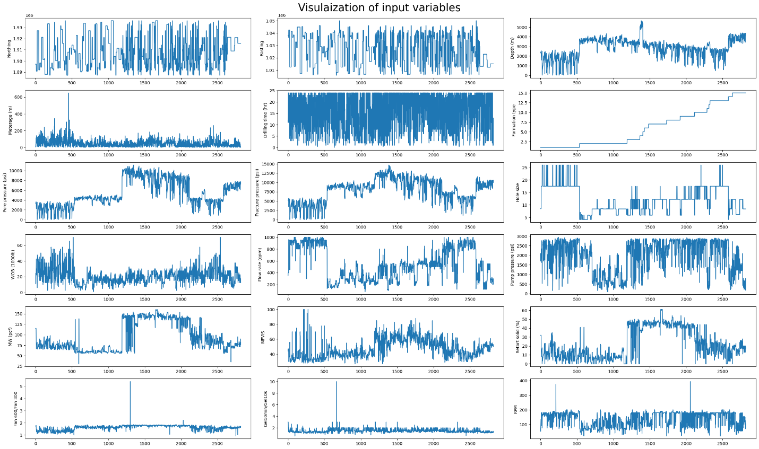
Figure S1. Visualization of input features

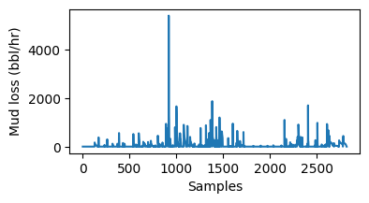
Figure S2. Visualization of output variable
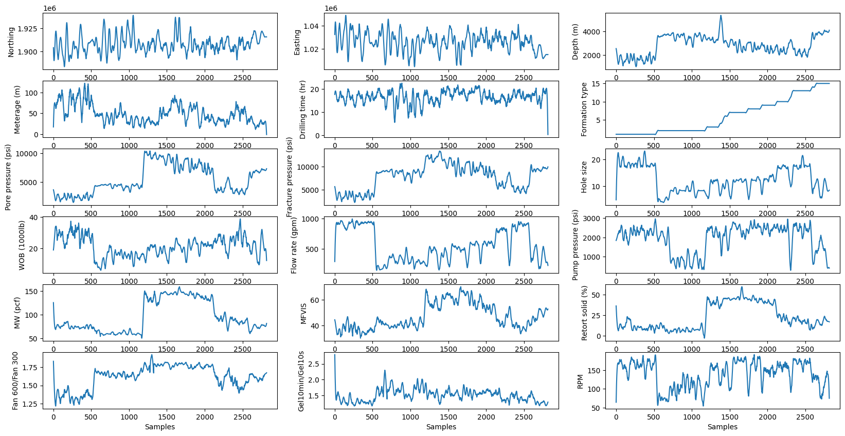
Figure S3. Visualization of smoothed input features

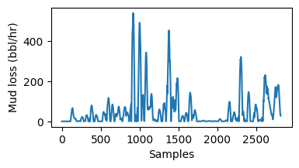
Figure S4. Visualization of smoothed output variable
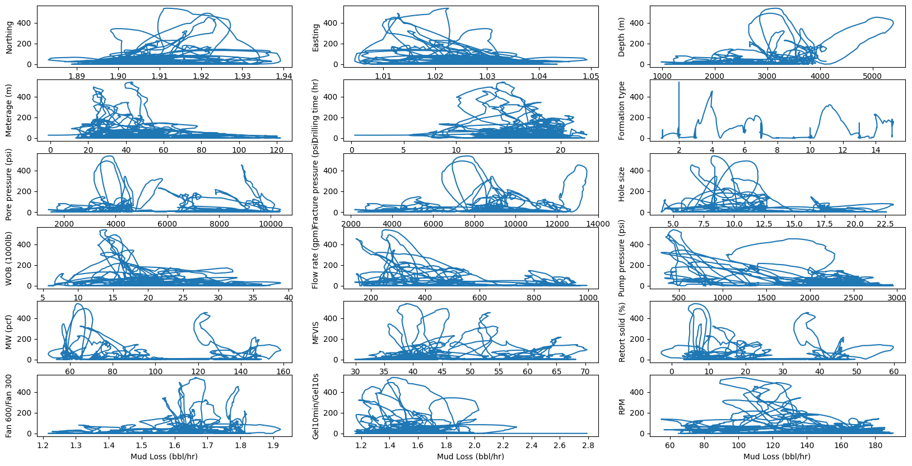
Figure S5. Relation between each input feature and the output variable

